# Design Overview for Hospital Management System

Name: Nguyen Duc Thang

Student ID: 104776473

# Summary of Program

Describe what you want the program to do… one or two paragraphs.

Include a sketch of sample output to illustrate your idea.

This program will illustrate the functionality of how Hospital manage the client and also the staff inside that hospital.

Sketch:

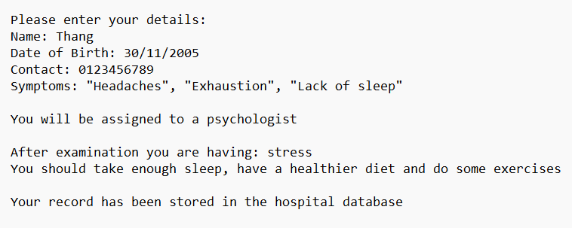

# Required Roles

Describe each of the classes, interfaces, and any enumerations you will create. Use a different table to describe each role you will have, using the following table templates.

Table 1: <<role name>> details – duplicate

|  |  |  |
| --- | --- | --- |
| Responsibility | Type Details | Notes |
| _medical_staff:  _patient:  _receptionist:  _patient_record: _issue_date:  _is_valid:  _name:  _contact:  _dob:  _symptoms:  _working_hours:  _experience:  Hospital()  Manage()  PatientRecord()  Receptionist()  Person()  Patient()  Nurse()  SurgicalNurse()  PediaricNurse()  EmergencyNurse()  MedicalStaff()  Surgeon()  Pediatric()  Cardiologist()  Psychologist()  MedicalStaffFactory | MedicalStaff  Patient  Receptionist  PatientRecord  DateTime  Bool  String  String  DateTime  string[]  string  string  void  void  void  void  void  void  void  void  void  void  void  void  void  void  void  void | Include information about doctors and nurse  Include patient information and symtoms  Include information and roles of a receptionist  Include: date and description given to the patient  Contains the day, month and year  Check if the record is from a medical staff or not  Name of patient or medical staff  Phone number of the person  Date of birth of the person  Problem the patient are having  Time that a medical staff will be on  Number of years in the job  Contains patient and medical staff data  Control how many medical staff are available and enable patient record and find it  Contains feedback given from the medical staff  Can add and remove a patient record  Abstract class represent a human information  Include patient’s personal information and symtoms  A medical staff that will update the patient record  A type of nurse will update feedback from a surgeon  A type of nurse will update feedback from a pediatric  A type of nurse will update feedback from others doctor type  Abstract class inherit from person class  Will give feedback to the patient  Will give feedback to the patient  Will give feedback to the patient  Will give feedback to the patient  Create a new Medical Staff |

Table 2: <<enumeration name>> details

|  |  |
| --- | --- |
| Value | Notes |
|  |  |

# Class Diagram

Design patterns used:

* Observer Pattern (IOserver interface implemented by medical staff)
* Factory Pattern (MedicalStaffFactory creates various types of medical staff that will make the system more maintainable and also scalable)
* Strategy Pattern (Allow different treatment plans which allow flexibility in treatment strategies)

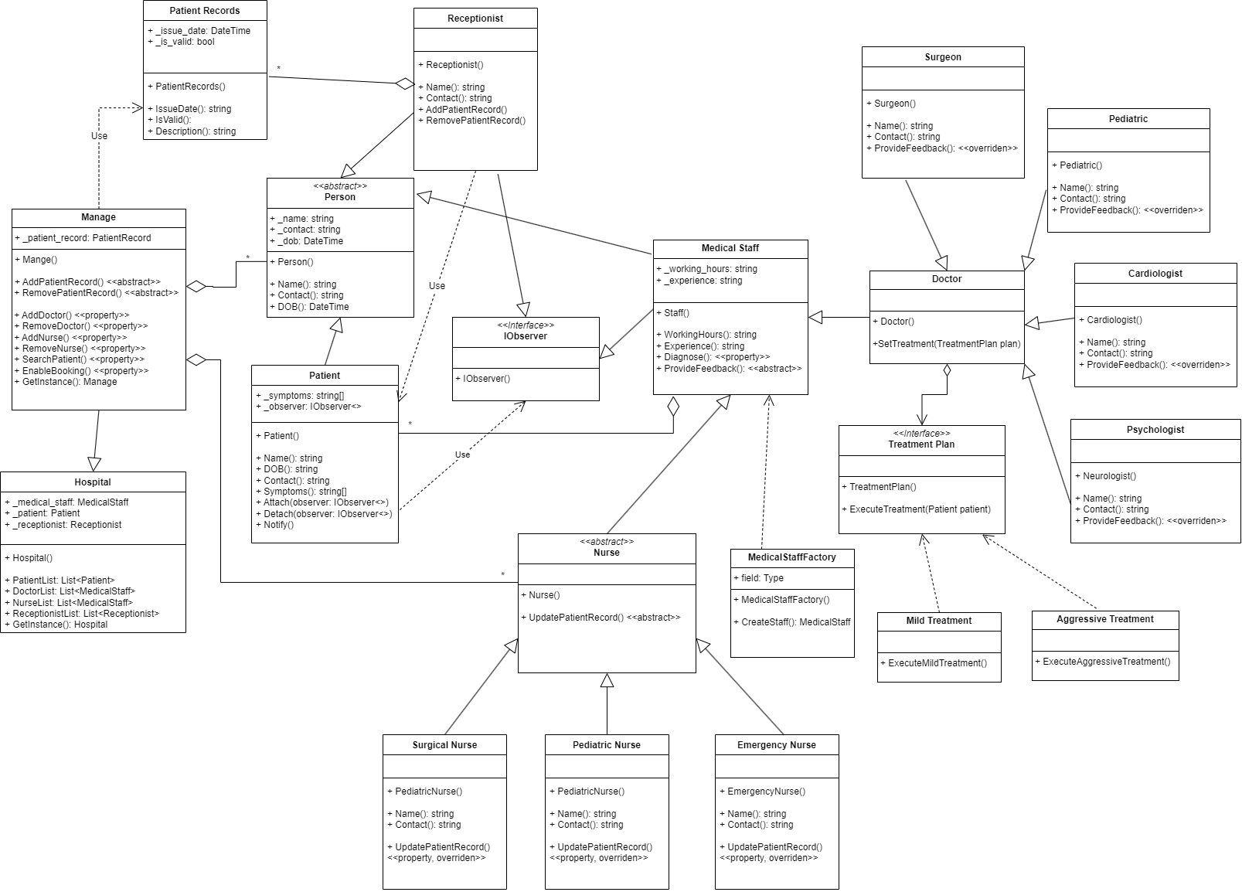

# Sequence Diagram

